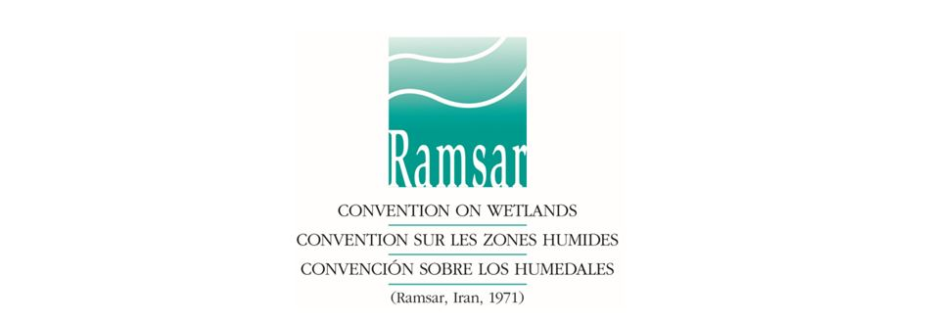

Call for Proposal
Social Media Coordinator

BACKGROUND
The Ramsar Convention on Wetlands is an intergovernmental treaty that provides the framework for national action and international cooperation for the conservation and wise use of wetlands and their resources. The Convention today has 170 Contracting Parties (member countries).

Wetlands are among the most diverse and productive ecosystems. They provide essential services and supply all our fresh water. However they continue to be degraded and converted to other uses.

The Convention uses a broad definition of wetlands. It includes all lakes and rivers, underground aquifers, swamps and marshes, wet grasslands, peatlands, oases, estuaries, deltas and tidal flats, mangroves and other coastal areas, coral reefs, and all human-made sites such as fish ponds, rice paddies, reservoirs and salt pans.

The Contracting Parties implement the Ramsar Convention in their territories and collaborate on shared projects. The government agency responsible for its national application is known as the country’s Administrative Authority. The scope and focus of the Convention’s work is coordinated by means of a Strategic Plan and associated work plans which set out priority objectives and the actions expected or requested of the various bodies of the Convention.

Every three years the Parties meet at the Conference of the Contracting Parties (the COP), where they adopt decisions to administer the Convention and guide its implementation.
The 13th Meeting of the Conference of the Contracting Parties to the Ramsar Convention on Wetlands (COP13) will take place from 21 to 29 October 2018 in Dubai. The theme of COP13 is “Wetlands for a Sustainable Urban Future”.

On average 1,000 participants attend COP, these are: Contracting Party Delegations, Government Agency Observers, Observer Sates, Intergovernmental and International Organizations, International NGOs, Academia, Business representatives, media.

The Global Wetland Outlook (GWO) is the Convention’s new flagship publication, which will be launched in October 2108, before COP13. It will be a strategic assessment providing a transformative vision for wetland management practice, policy and planning at global and national scales.

The Ramsar Secretariat currently uses four social media channels: Twitter, Facebook, Instagram and YouTube.

CONSULTANT’S TASKS AND DELIVERABLES
Under the overall supervision of the Director Resource Mobilization & Outreach Ramsar Secretariat, the consultant will carry out the following tasks related to social media coordination:

- Develop a targeted social media strategy and work plan for COP13 taking into account COP13 theme, the launch of the Global Wetland Outlook and wetlands’ role in achieving SDGs;
- Develop a social media pack and share it with Ramsar Convention partners;
- Establish a daily content planning for COP13 campaign and develop social media micro-content;
- Roll out the campaign starting one month prior COP13 (a count-down to COP), during COP13 in Dubai (21 to 29 October 2018) and 2 weeks after COP using three channels: Facebook, Twitter and Instagram;
- Live-tweet and live-Facebook coverage of the most important events during COP13 such as the High Level Panel, Ramsar Awards, COP13 Opening Ceremony, Global Wetland Outlook launch, press conferences, COP13 Declaration, high-level side events;
- Monitor, measure and prepare a wrap-up report on COP13 social media campaign audience and impact, and make recommendations for how to respond to the analysis;
- Advise on new ways for Ramsar to increase its effectiveness through social media.

SELECTION CRITERIA
The consultant should have:
- A minimum 5 years working experience in social media, including a sound experience in live-tweeting using an IPad;
- Knowledge and experience in using Sprout Social platform;
- Experience and ability to work independently in a fast changing event environment;
- Excellent command of both written and spoken English, preferably English native speaker;
- Experience with environmental organizations and issues.

TERMS OF ENGAGEMENT
- The contract would cover a period of 3 months: from 15th August, 2018 to 15th November, 2018
- The consultancy is based at the Ramsar Secretariat Office in Gland, Switzerland, 4 days per week and full time from 19 to 30 October 2018 in Dubai, UAE (dates of COP13). Travel costs to/from Dubai for COP13 will be paid by the Convention.
- All products developed and delivered through this consultancy shall remain the exclusive property of the Ramsar Convention, and shall not be divulged and/or used without prior written authorization;
- 3-month contract of CHF 20K paid in three monthly instalments at the end of each month worked.

Expression of Interest
All interested and qualified consultants are encouraged to submit their credentials and a supporting letter of motivation in English. The letter should specifically address the selection criteria presented above, and provide the names/contact details of three referees, including one recent employer.

All expressions of interest should be submitted by email, before 20 June 2018 5pm Swiss Time, to: ramsar@ramsar.org

Proposals received after the deadline will not be considered. Proposals may be amended or withdrawn at any point prior to the submission deadline, but cannot be revoked or changed thereafter.

